introduction to control systems
PREPARED BY
Tyler Long
In partial fulfillment of the requirements for
ECET 4610
PREPARED BY:
APPROVED BY:
September 14, 2008
SOUTHERN POLYTECHNIC STATE UNIVERSITY
Quizzes:
Question 1
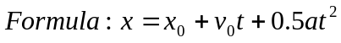
Matlab Work:
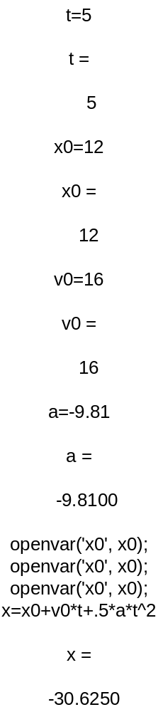
Question 2
Matlab Work:
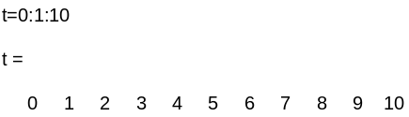
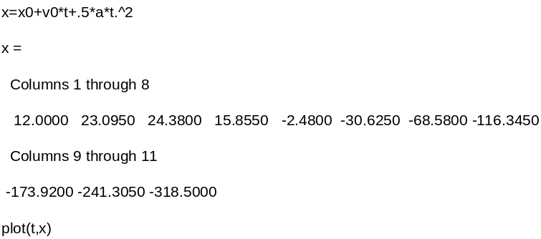

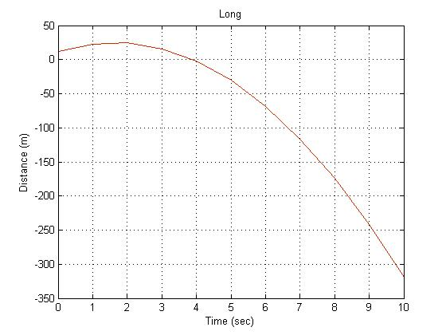

Question 3
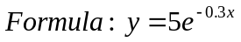
Matlab Work:
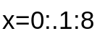
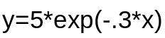
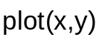
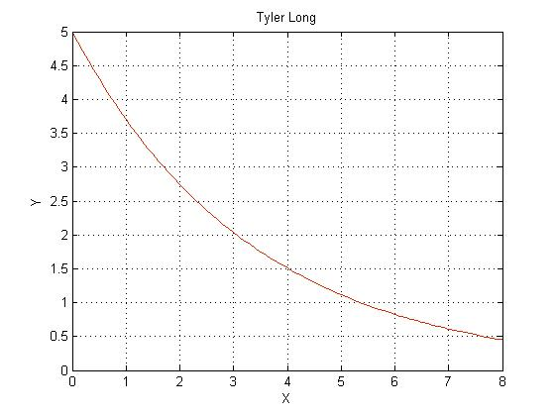

Question 4
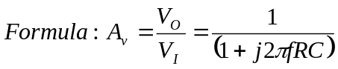
Matlab Work:
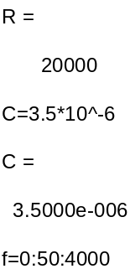
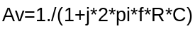
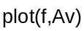
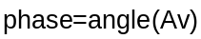
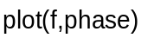
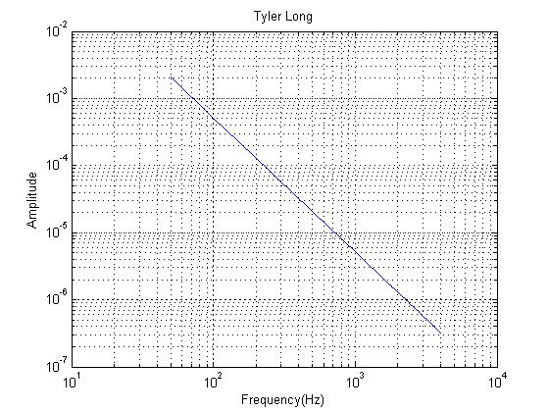
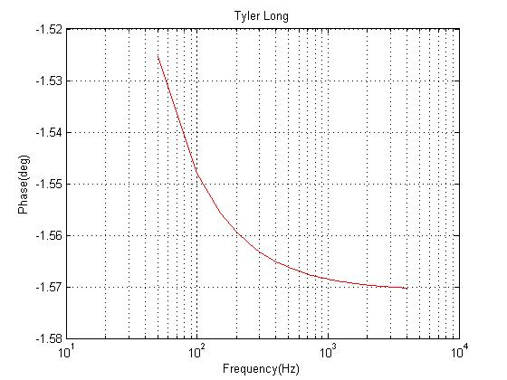
Question 5
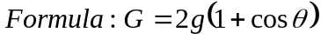
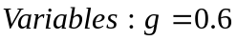
Matlab Work:
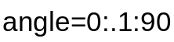

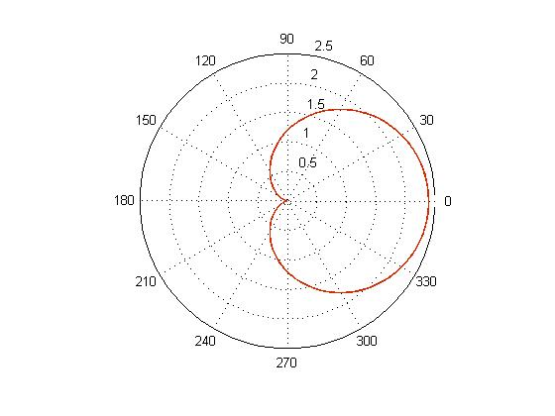

Question 6
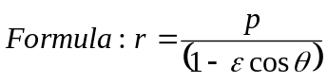
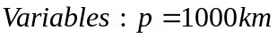
Matlab Work:
